A000-Indus-Bowl-Two Fishes-3000 BCE

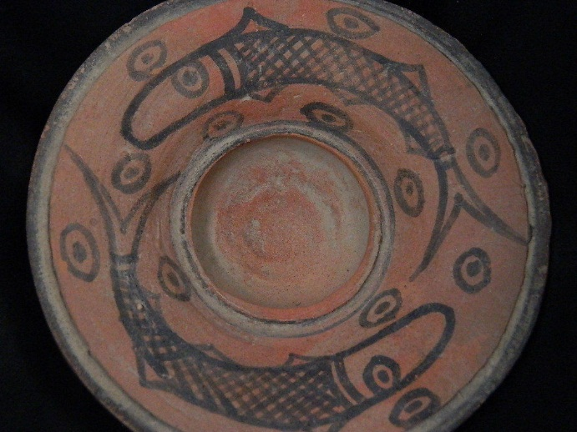 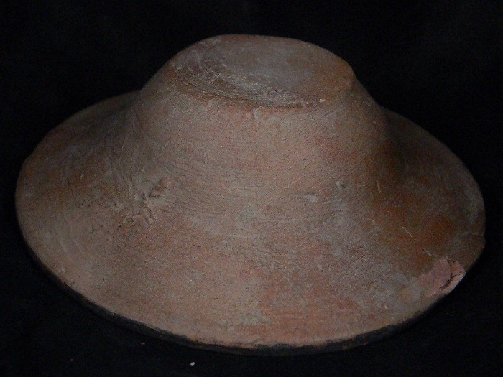

**Formal Label: Indus Bowl with Two Fishes, ca 3000 BCE**

**Case No. 3**

**Accession Number: A….**

**LC Classification:** DS425

**Date or Time Horizon:** ca 3000 BCE

**Geographical Area:** Indus Valley

**Cultural Affiliation:** Indus Civilization

**Medium:** Terracotta

**Dimensions: H 3.5 cm; Dia. 12.5 cm**

**Weight:**

**Provenance: Ex European Collection, 1970-2016.**

**Condition:** Slight nicks on rim.

**Discussion: From:** Napat 2016a, Napat 2016b

# Matsya - The Fish. Long ago, the world was about to be destroyed by a great flood. Vishnu, who knew this fact, decided that mankind needed his help, if it had to survive this calamity. He therefore transformed himself into a fish (Matsya) and entered the river.

Along the banks of this river, a king named Swayambhuva Manu (he is the same Manu who is credited with Manu-neethi, or the laws of Manu, and is the person who codified the laws for mankind), was performing a long and arduous penance.

Swayambhuva Manu is the first of the fourteen Manus, who each preside over a time that is slightly larger than 71 Chatur-Yugas. He was created by Lord Brahma, along with a woman named Sataroopa, who became his wife. They had five children: two sons named Priyavritha and Uttanapada, and three daughters named Aahuti, Devahuti, and Prasuti.

Lord Brahma appointed him to rule over the earth, which was at that time at the bottom of the great ocean. Heeding to the prayers of the Devas, Lord Vishnu undertook the Varaha avatar and brought the earth back, making it float on the great-ocean.

His daughter Aahuti was given in marriage to a Prajapati called Ruchi. They had twins: a daughter named Dakshina, who was portion of Laxmi power, and a son who was an incarnation of Lord Vishnu.

When the king was collecting water from the river, he saw that he had caught a tiny little fish into his kamandal (a vessel that is used to store water used for prayers/devotion). He was about to throw the fish back to the water, when it beseeched him not to send it back to the river, for it was afraid that it would not survive there. The king took pity on it and took it back with him to palace, deciding to keep it in his kamandal.

The next day, he was very much surprised to see that the fish had grown so large, that it was covering the whole vessel! He then transferred it to a small tub. The fish continued to grow and filled the tub in no time. The King kept transferring it to a bigger and bigger container, but the fish continued to grow. At last, it had grown so big, that only the ocean could hold it. The King realized that the fish must be some divine being. He prostrated himself before it and sought enlightenment.

The fish revealed itself to be Lord Vishnu. It said, "O Manu, know that in a very short while, storm clouds shall gather over this land. Rain will fall, the likes of which has never been seen before. This rain will be the agent of destruction, and will submerge the whole world and destroy all living beings. I have decided that you should be the person who will preserve the seed of humanity into the new world. When the flood subsides, a new world shall emerge and the task of populating this world with all creatures, will be yours. Build a great ship, and fill it with worthy people, and plants and animals of every kind. When the rain starts, I shall personally guide you to safety in my form as a fish."

The king thanked Vishnu for the great honor bestowed upon him. He began to make preparation to survive the great flood. The appointed day came. Clouds completely filled the sky. The rain began. It was so ferocious, that you could not see more than a few feet ahead. Lightning and thunder were the only things that broke the monotony of the sound of falling water. The King, along with the chosen people/animal/plants was safe abroad the ship. He had to steer the ship, in the storm, but he did not know where he was to go. Waves as large as mountains were buffeting the ship. As promised, Vishnu, as the Matsya, steadied the ship from behind. He guided the ship for seven days and seven nights. At last the rain stopped, the water took some more time to subside, and the land peeped out from under its watery prison.

As promised, Manu and his followers had been saved, and began the task of procreation, to fill the new world. This ended Vishnu's Matsya avatar. He was the first ruler of mankind in this new world.

This story resembles that of "Noah's ark" in Genesis. Disparate civilizations have the concept of the cosmic flood woven in their mythology. Researchers speculate that there really might have been a great flood in the distant past, that has supplied the basis for all these stories about a cosmic deluge that submerged the entire world.

[Comment: The bowl with two fishes suggests that this is a set ritual piece that precedes the story above (ca 1250 BCE) by perhaps 1750 years, and that the two fishes represent the unfolding of the new earth from the depths of the great flood, hence a new beginning for those who sip the water contained within the bowl.]

**References:**

Napat, Apam**.** 2016a. *Matsya - The Fish.* <http://www.apamnapat.com/articles/Dasavatar00b.html>

# Napat, Apam, 2016b. *Swayambhuva Manu - The First Manu.*

# http://www.apamnapat.com/entities/Manu_Swayambhuva.html